AGENDA
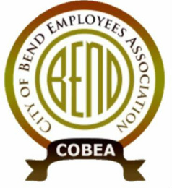
Meeting: COBEA EBoard Meeting
Date: 12/15/2021, 4:30 PM – 6:30PM
Attendees:
❍ Kerry Bell – President  Julie Craig -Vice President  Julie Oconnor – Secretary  Sean Quinlivan – Treasurer
Nick Patten – ST Downtown main campus  Matt Ziebol - ST Boyd  Mike Niles - ST Wall Annex  Roy Bradley - ST WRF  Nolan Holmgren – ST 15th alternate  Lori Davison – downtown main alternate  Joe Holmgren – Boyd alternate  Lanelle Duran – Wall Annex alternate  Cally Whitman – WRF alternate  Tedesco Law Firm - Representation

Call to Order: President
REPORTS: (30min)
1. Officer Reports
- Secretary Report (3min) –
- Treasurer Report (3min) -
- Vice President Report (3min) -
- President Report (20?min) - investigation into ethics and job performance - termination, member pushed out and request for investigation, PDQs, contracted third party for plan review
vISITOR cOMMENTS
New GENERAL Business: (up to 1.5 hrs)
- Training for 2022, Cally’s info
- Budget for 2022
OLD General business (.5hr)
- New HIre orientations
- Fair pay study
- Elections
- Bargaining
Upcoming Meetings: Board meeting January 19th , Membership Quarterly meeting January 27th
Steward Reports: (ROUND TABLE up to 3min each as time has allowed)
Close Meeting

