**10/1/2016 – 6/30/2019**

Collective Bargaining Agreement

Between

# City of Bend Employees Association

# And the

City of Bend

Contents

City of Bend Employees Association 1

And the 1

PREAMBLE 1

ARTICLE 1 – RECOGNITION 1

ARTICLE 2 - WAIVER AND SCOPE 2

ARTICLE 3 - ASSOCIATION RIGHTS 2

ARTICLE 4 - MANAGEMENT RIGHTS 4

ARTICLE 5 - CITY SECURITY 4

ARTICLE 6 – NON-DISCRIMINATION 4

ARTICLE 7 - WORK SCHEDULES 5

ARTICLE 8 – OVERTIME AND STANDBY TIME/ON CALL 8

ARTICLE 9 - PROBATION 9

ARTICLE 10 – COACHING, COUNSELING AND FORMAL DISCIPLINE 10

ARTICLE 11 - GRIEVANCE PROCEDURE 11

ARTICLE 12 - PERFORMANCE EVALUATIONS 13

ARTICLE 13 - SALARY ADMINISTRATION 13

ARTICLE 14 - PAYDAY 15

ARTICLE 15 - PERSONNEL RECORDS 15

ARTICLE 16 – LAYOFF 16

ARTICLE 17 - SENIORITY 17

ARTICLE 18 - LEAVE OF ABSENCE 18

ARTICLE 19 - HOLIDAYS 19

ARTICLE 20 ‑ SICK LEAVE 20

ARTICLE 21 – VACATIONS 21

ARTICLE 22 ‑ HEALTH AND WELFARE 22

ARTICLE 23 – RETIREMENT 25

ARTICLE 24 - CLOTHING, UNIFORMS, AND PERSONAL SAFETY EQUIPMENT 26

ARTICLE 25 - SCHOOLS, SEMINARS, TRAINING 27

ARTICLE 26 ‑ SAFETY 27

ARTICLE 27 - OUTSIDE EMPLOYMENT 27

ARTICLE 28 – SAVINGS CLAUSE 28

ARTICLE 29 ‑ TERM OF THE AGREEMENT 28

ARTICLE 30 – SALARY 28

Performance Pay Program (PPP) 29

Appendix A (Effective 10/1/2016) 30

**Appendix B** (Effective 07/01/2017) 33

Appendix C (Effective 07/01/2018) 36

Memorandum of Understandings 46

# PREAMBLE

This Agreement is made and entered into by and between the City of Bend (hereinafter the “City”) and the City of Bend Employees Association, (hereinafter “COBEA”).

It is the purpose of this Agreement to achieve and maintain a harmonious relationship between the City and COBEA, to provide for equitable and peaceful adjustment of differences which may arise, and to establish proper standards for wages, hours, and other conditions of employment.

The mailing address of the City shall be "City of Bend, 710 NW Wall Street, Bend, Oregon 97703”. The mailing address of COBEA shall be "City of Bend Employees Association, P.O. Box 1384, Bend, Oregon 97709”.

# ARTICLE 1 – RECOGNITION

Section 1.1 Recognition. The City recognizes COBEA as the sole and exclusive representative with respect to wages, hours, benefits, and mandatory conditions of employment for all employees included in the bargaining unit. The purpose of this Article is to recognize the right of the bargaining agent to represent City employees in the bargaining unit in negotiations with the City.

Section 1.2 Bargaining Unit. Employees who are subject to the terms of this Agreement shall include employees whose job titles are included in COBEA salary schedule within this Agreement whose positions are (1) Regular full-time and (2) Regular part-time. Employees hired into Limited Term positions are subject to the terms of this Agreement, excluding Article 16 – Layoff, and Article 17 – Seniority. Benefits, accruals and other conditions of employment for regular part-time COBEA members who work an average of 20 - 29 hours per week shall be pro-rated at 50% of the level provided to full time members and for part time COBEA members who work an average of 30 - 39 hours per week shall be pro-rated at 75% of the level provided to full time members.

Section 1.3 Bargaining Unit Exclusions.

Section 1.4 City Notification. The City, when exercising the right to create, reclassify and/or combine positions shall notify COBEA in writing and in a timely manner. COBEA will have 15 business days to formally respond upon receipt of notification by the City. If a dispute exists concerning the appropriateness of inclusion or exclusion of a position, the parties shall meet to discuss the issues within the 15 day period. If, after the 15 day period expires, and the dispute remains, either party may petition the Employment Relations Board for unit clarification. Consistent with ORS 243.698, the City will not be precluded from hiring the position at the posted wage, however, the City recognizes the obligation to bargain and honor any interest arbitration decision.

# ARTICLE 2 - WAIVER AND SCOPE

Section 2.1 This Agreement shall not be modified in whole or in part except by an instrument, duly executed by both parties.

Section 2.2 Complete Agreement. This contract constitutes the sole and entire existing Agreement between the parties and completely and correctly expresses all rights and obligations of the parties.

# ARTICLE 3 - ASSOCIATION RIGHTS

Section 3.1 Employees shall have the right to form, join, and participate in the activities of employee organizations of their own choosing, for the purpose of representation on matters of employee relations. Employees shall also have the right to refuse to join or participate in the activities of any employee organization. No employee shall be interfered with, intimidated, restrained, coerced, or discriminated against by the City or by an employee organization because of their exercise of these rights.

Section 3.2 Membership / Fair Share

(a) Terms. The terms of this Agreement have been made for all employees in the bargaining unit and not only for the members of COBEA. Accordingly, it is fair that each employee in the bargaining unit pay their own way and assume their obligation along with the grant of equal benefits.

(b) Dues. The City, when so authorized and directed in writing by the Secretary of COBEA on the authorization form provided by the City, will deduct current Association dues from the wages of all employees in the bargaining unit.

(c) Check-off Errors. The City will not be held liable for check-off errors, but will make proper adjustments with COBEA for errors in the following pay period.

(d) Monthly Service Fee. Any regular employee who is a member of COBEA and has not joined the Association within (30) thirty days of becoming a regular employee shall have deducted from their pay by the City, as a condition of employment, a monthly service fee in lieu of dues in an amount certified to the City by the Association. This service fee shall be used on a pro-rata basis solely to defray the cost of its services rendered in negotiation and administering the agreement. Service fee deductions shall be made only if accrued earnings are sufficient to cover the service fee after all other authorized payroll deductions have been made.

(e) Religious Objection. The parties agree that the provision of ORS 243.666 shall be applied to employees who object to paying fair share payments on bona fide religious tenets or teachings of a church or religious body. An individual employee who establishes such religious beliefs and does not join the Association and objects to paying fair share to the Association based on a bona fide religious tenet or teaching of a church or religious body of which the employee is a member shall not be required to pay dues or fair share payments; but such employee shall be required to pay an amount equivalent to fair share to a non-religious charity or to another charitable organization mutually agreed upon by the employee and the Association. The employee shall furnish written proof to the City and the Association that this has been done.

(f) Itemized Statement. The aggregate deductions of all employees together with an itemized statement shall be remitted to the President or Secretary of COBEA no later than the tenth (10) of the month following the month for which the deductions were made. The itemized listing of COBEA members shall reflect employee terminations, retirements, cancellations, leave without pay, return from leave without pay, new members, fair share members, salary changes, name changes, and/or any other personnel action, which would affect the amount of dues withheld.

Section 3.3 Association Representatives. The Association agrees that members of the Association selected to serve as official representatives will be certified in writing to the Human Resources Manager. Association representatives shall be expected to perform their duties on their own time but, they, with their immediate supervisor’s approval, may be granted time off with pay to perform their duties as long as the requests are reasonable and do not unduly disrupt the operations of the City.

Section 3.4 Bargaining Committee. The number of COBEA’s collective bargaining committee members shall be equal to the City’s bargaining team Committee and shall be granted time off with pay to negotiate with the City (minimum of five (5) employees for each party). All City-paid work time authorized by this agreement spent performing COBEA related activities shall be recorded as such on the employee’s time record. Regular work time spent performing COBEA related activities but not authorized as City-paid in this agreement shall be charged against the employee’s accrued leave.

Section 3.5 Bulletin Board. The City shall maintain reasonable (number, size and location) bulletin board space designated for the exclusive use of COBEA in communicating with Association members restricted to Association business, training benefits, education or other COBEA announcements. The Association shall limit its posting of notices and bulletins to such bulletin board space; all postings will be stamped with Board approval prior to posting. The Association shall periodically clear the board of outdated materials. All such postings shall promote good relations between the parties and be non-inflammatory in nature.

Section 3.6 Representation & Handbook. The City agrees to inform all new bargaining unit Employees of COBEA's exclusive representation status and shall provide all new employees with a digital version of the City’s Employee Handbook.

Section 3.7 COBEA Orientation. An authorized representative of the Association shall be allowed one hour of informational welcome time with newly employed staff appointed to COBEA represented positions. The meeting shall occur within the first thirty (30) days following appointment and be scheduled in advance.

Section 3.8 City Email System. The parties recognize that the City’s email system is the sole property of the City. This resource is provided or assigned to employees to facilitate the orderly and efficient conduct of the public’s business. Permitted email use constituting public business includes such labor relations activities as described below. In general, all such communications may be subject to disclosure, and the parties recognize that the City does not have an obligation to assert any exceptions or exemptions from disclosure as to public records that happen to contain information relating to Association activity by City employees. The parties recognize that the City may review all City emails in the City system at any time.

Certified Association Officers may use the City’s email system to conduct labor relations business for the limited purposes of:

* 1. Notifying Association members of meetings and scheduling meetings (date, time, place and agenda)
  2. Scheduling meetings among Association Officers (date, time, place and agenda)
  3. Filing official correspondence with the City (i.e., grievance documents, demand to bargain notices), provided however that timelines for grievance responses shall run from receipt (the date an email is sent)
  4. Communication between the Association attorney, Certified Association Officers and City Officials
  5. Notifying members of all Association related events, bargaining related matters, and other official Association business announcements.

Such City email communications shall be specifically identified in the Subject Line as Labor Relations Business in addition to any other topic.

The City retains control over the City email system and may restrict or revoke permission to use the City email for labor relations purposes at any time after meeting and discussing such decision and the City’s reasons. Association officers and members will keep on-duty use of email for labor relations purposes (sending/reading) to a minimum.

The parties recognize that use of the City’s email systems outside of what is authorized in this Section is considered a violation of policy.

Section 3.9 Job Opportunity Notice. The City shall take reasonable steps to afford members of COBEA notice of all regular job openings within the City.

# ARTICLE 4 - MANAGEMENT RIGHTS

Except as otherwise expressly and specifically limited by the terms of this Agreement, the City retains all their customary, usual and exclusive rights, decision making, prerogatives, functions, and authority connected with or in any way incidental to its responsibility to manage the affairs of the City or any part of the City. The rights of employees in the bargaining unit and COBEA hereunder are limited to those specifically set forth in this Agreement, and the City retains all prerogatives, functions, and rights not specifically limited by the terms of the Agreement. Should the City need to use the expedited bargaining process as required by ORS 243.698, the parties agree to modify section 4 in that the bargaining need not take more than thirty (30) days and mediation is waived, unless the parties mutually agree to utilize it. After 30 days, if it wishes to do so, the City can implement all or part of its final offer.

# ARTICLE 5 - CITY SECURITY

COBEA and its members, as individuals or as a group, will not initiate, cause, permit, or participate or join in any strike, work stoppages, slowdown, picketing, or any other restriction of work except as provided by law.

# ARTICLE 6 – NON-DISCRIMINATION

Section 6.1 The provisions of this Agreement shall be applied equally to all employees in the bargaining unit without discrimination as to race, color, religion, sex, pregnancy, national origin, ancestry, citizenship, age, marital status, physical disability, mental disability, veteran's status, medical condition, sexual orientation or gender identity, expunged juvenile record, genetics, political or union affiliation and/or other protected status unrelated to job performance. . Each party shall share, within the limits of their responsibility, the application of this provision of the Agreement.

Section 6.2 The City and COBEA agree not to discriminate against any employee for their activity or non-activity on behalf of, or membership in COBEA.

Section 6.3 All references to employees or officers in this Agreement designate both sexes, and wherever the male gender is used, it shall be construed to include male and female employees.

# ARTICLE 7 - WORK SCHEDULES

Section 7.1 FLSA Workweek. The regular workweek shall consist of seven (7) consecutive days. The workweek shall start at midnight on Sunday and end at 11:59 PM on Saturday. The workweek shall include a minimum of two consecutive days off. Alternate workweeks may be established with mutual agreement between the parties.

Section 7.2 Notification of Schedule Changes. Established regular work schedules will not be changed with less than ten (10) working days advance notice, except in the following circumstances:

1. for the duration of an emergency; or
2. to accommodate the operational need to coordinate work with an external agency; or
3. the notice is voluntarily waived in writing by the employee(s).

Section 7.3 Preparation/Clean Up. The workday is defined as a twenty-four (24) hour period, commencing at 12:00 midnight on the employee's scheduled shift day. Each shift shall have regular starting and quitting times. Within the workday, clean-up time for City equipment and tools is at the discretion of the employee's supervisor. Personal clean-up time shall be provided up to a maximum of fifteen (15) minutes at the end of the scheduled shift. Personal clean-up time shall be afforded only when necessitated by the nature of the work assignment and shall not be provided for any purpose other than to clean personal property required for on-the-job performance or City property assigned for personal use. An employee is expected to be properly dressed and ready for work at the beginning of the work shift, and to work until the end of the assigned shift unless otherwise directed.

Section 7.4 Regular Work Schedules. The work shift for full-time employees shall consist of one of the following:

1. An eight (8) -hour work period exclusive of authorized meal periods.
2. A ten (10) -hour work period exclusive of authorized meal periods.
3. A bi-weekly work schedule consisting of four (4) consecutive ten (10)-hour days on with three consecutive days off, followed by five consecutive eight (8)-hour workdays with two (2) consecutive days off.
4. An eight (8)-hour work period inclusive of a paid thirty (30)-minute meal period, any portion of which falls between 6:00 pm and 6:00 am, and the entire period from 6:00 pm Friday until 6:00 am on Monday.
5. A ten (10)-hour work period inclusive of a paid thirty (30)-minute meal period, any portion of which falls between 6:00 pm and 6:00 am, and the entire period from 6:00 pm Friday until 6:00 am on Monday.

(f) A 9/80 schedule which consists of working eight days of nine hours, one day of eight hours, with the tenth day off (flex day) in a two-week period. The workweek for employees on a 9/80 schedule runs for seven days. The beginning of the work week is the midpoint of the first eight-hour day and runs for seven consecutive days ending at the midpoint of the seventh day.

The employee’s schedule maintains regularly scheduled work hours of no more than 40 per workweek.

There are four variants of this schedule as shown in the Tables below:

Table 7.4.100

9/80 – First Friday Off

|  |  |  |  |  |  |  |
| --- | --- | --- | --- | --- | --- | --- |
| Mon | Tue | Wed | Thur | Fri | Sat | Sun |
| 9 | 9 | 9 | 9 | 0 / 0 | 0 | 0 |
| 9 | 9 | 9 | 9 | 4 / 4 | 0 | 0 |

Table 7.4.200

9/80 – Second Friday Off

|  |  |  |  |  |  |  |
| --- | --- | --- | --- | --- | --- | --- |
| Mon | Tue | Wed | Thur | Fri | Sat | Sun |
| 9 | 9 | 9 | 9 | 4 / 4 | 0 | 0 |
| 9 | 9 | 9 | 9 | 0 / 0 | 0 | 0 |

Table 7.4.300

9/80 – First Monday Off

|  |  |  |  |  |  |  |
| --- | --- | --- | --- | --- | --- | --- |
| Mon | Tue | Wed | Thur | Fri | Sat | Sun |
| 0 / 0 | 9 | 9 | 9 | 9 | 0 | 0 |
| 4 / 4 | 9 | 9 | 9 | 9 | 0 | 0 |

Table 7.4.400

9/80 - Second Monday Off

|  |  |  |  |  |  |  |
| --- | --- | --- | --- | --- | --- | --- |
| Mon | Tue | Wed | Thur | Fri | Sat | Sun |
| 4 / 4 | 9 | 9 | 9 | 9 | 0 | 0 |
| 0 / 0 | 9 | 9 | 9 | 9 | 0 | 0 |

* The workweek begins at the midpoint of the eight-hour day [noted as / in the above examples]. Each workweek is scheduled for 40 regular hours.

Assignment of the 9/80 schedule is at the sole discretion of the City and must be voluntarily agreed to by the employee.

Employees authorized to work a 9/80 schedule must receive prior written approval to modify any part of their regular work schedule from the supervisor prior to working any modified hours. Employees are responsible for designating which workweek hours are worked on the split work-week day (e.g., the 4/4 day) on their timesheets.

Transition to and from a 9/80 schedule requires management consultation with Payroll in order to ensure accurate payment of wages.

All employees on 9/80 schedules will receive a memorandum containing the terms of the schedule and will sign it indicating understanding of the terms.

When a City Holiday falls on an employee’s regularly scheduled nine hour day, the employee must account for the additional hour of scheduled work in one of the following options:

1. Use accrued vacation, holiday, or compensatory time.
2. Receive approval from their supervisor to add the hour of work onto another day within the same workweek.

The paid lunch period in items (d) and (e) is not applicable to overtime worked that is either an extension of a regular work shift described in (d) and (e) or separate from an employee’s scheduled regular work hours.

Part time employees will have an established work schedule that may not correspond with the work schedules described above.

Section 7.5 Lunch Period. All full time employees' schedules shall provide for a thirty (30) or sixty (60) minute unpaid lunch period as determined by the division manager or designee, except as provided in Section 4 (d) and (e). The work schedule for part time employees working six consecutive hours or more per shift shall provide for a 30 or 60-minute unpaid lunch period as determined by the division manager or designee. The division manager or designee may require employees to exercise their lunch periods at various City locations in order to avoid lost work hours because of travel time. Such locations shall be equipped with basic sanitary facilities.

Each employee is expected to take the appropriate amount of time for each break and lunch period.

Section 7.6 Break Periods. All full time employees' work schedules shall provide for a twenty (20) minute rest period during each one-half (1/2) shift. Employees who are afforded a rest period, who by choice do not exercise that right, shall not be entitled to any form of compensation in lieu of the authorized rest period. Part time employees who work less than an eight (8) hour work shift shall be provided a 20-minute rest period during each four (4) hour work period.

Section 7.7 Wellness Program. Employees may, with prior supervisory approval, reduce their twenty (20) minutes rest periods in Section 6 by 10 minutes each (for a total of 20 minutes) and aggregate the 20 paid minutes to their unpaid lunch period in Section 5 for the purpose of wellness activities such as attending physical fitness classes, facilities or other related programs. Under no circumstances shall the transfer of these minutes’ result in more City-paid time off work than would have otherwise been authorized under Section 5 & 6. By electing this option, employees must also take their remaining10 minute rest periods pursuant to Section 6.

Section 7.8 Employee Hour Substitution Requests Within a FLSA Workweek or Within a Workday.

Within a Workday: Employees may request to modify their start and stop times to meet personal needs. Such modifications must adhere to the other requirements of this Article (Sections 1 to 3, and 5 to 6).

Within a Workweek: Employees may request to work fewer hours than scheduled on one day in an FLSA workweek and make up for those hours by working an equivalent number of additional hours on another day in the same FLSA workweek.

These scheduling changes are subject to the approval of management, and regardless of any other provisions of this agreement, will not result in overtime pay or any additional costs to the City.

Section 7.9 Alternate Regular Work Schedules. Any work schedule other than those described in Article 7, Section 4, used for more than a week, shall be put in writing, approved by the employee’s direct supervisor outside the bargaining unit, the department head and Human Resources. A copy signed by all parties shall be placed in the employee’s personnel file.

Alternate work schedules include a flexible work schedule which is a work schedule, which varies the number of hours, worked on a daily basis, but not necessarily each day, or a work schedule in which starting and stopping times vary on a daily basis, but not necessarily each day, but which does not exceed forty (40) hours in a workweek.

Telecommuting for all or part of a workday is an alternate work schedule and must be in compliance with City policy.

An employee may be assigned or an employee may request to work an ongoing alternate work schedule if such is mutually agreed upon in advance by the employee and the City.

Alternate work schedule agreements shall be valid for a period up to one (1) year from the date of initiation. Upon the conclusion of one (1) year, a review of the agreement will be completed by employee and department manager or designee to discuss renewal or termination of the agreement. A request to adjust or terminate the agreement by either employee or management may take place at any time prior to the one (1)-year anniversary date. Management reserves the right to terminate the agreement at any time; however, flexible work schedules will not be changed with less than ten (10) working days’ advance notice, except where an emergency exists. Additional notice may be provided.

The parties agree that use of alternative schedules under this section does not set precedent for agreement to future schedules.

# ARTICLE 8 – OVERTIME AND STANDBY TIME/ON CALL

Section 8.1 Full-Time Employee. As used in this Agreement, for full time employees overtime shall mean that time an employee is authorized and directed to work:

1. in excess of their regularly scheduled hours for the day; or
2. in excess of a mutually agreed upon daily flexible schedule; or
3. on any regularly scheduled day off; or
4. in addition to a scheduled forty (40) hour shift week.

For the purpose of determining overtime due for hours worked in excess of the regularly scheduled hours for the day, sick leave shall not be considered hours of work.

Section 8.2 Part-time Employees. Overtime for part time employees shall be that time the employee is authorized and directed to work in excess of forty (40) hours in a work week.

Section 8.3 Overtime Exempt Employees. Employees appointed to the following positions are not subject to the overtime provisions of this Article:

Application Analyst

Business Analyst

Sr. Business Analyst

Performance Analyst

Senior Network Administrator

Network Administrator

GIS Analyst

Section 8.4 Rounding of Overtime. Overtime shall be computed to the nearest quarter hour.

Section 8.5 Overtime Rate. Overtime, whether taken as pay or time off, shall be compensated at the rate of time and one-half (1-1/2) the regular pay.

Section 8.6 Compensatory Time. Compensatory time may be accrued by agreement between the City and the employee. Such time off shall be granted at the rate of time and one half (1-1/2). Employees shall accurately record on their time sheet the agreed upon designation. The maximum compensatory time that an employee can accumulate is 80 hours. The City shall contribute the cash equivalent of all additional compensatory time hours in excess of the 80-hour maximum into the employee’s VEBA account on a monthly basis. Employees may request pay out of compensatory time. Granting of compensatory time payout is at the discretion of the City.

Section 8.7 Overtime Assignment. Overtime shall normally be voluntary unless an insufficient number of qualified employees volunteer, whereupon, overtime work will be assigned. Consideration will be given to employees with prior commitments that would conflict with the overtime period.

Section 8.8 Call Back. An employee who is not assigned to standby time/on call under Section 7 and who is called back to work outside the assigned work shift shall be paid at the rate of time and one-half (1-1/2) the employee’s regular rate of pay for a minimum of two (2) hours. If the call out occurs one (1) hour or less before or after the start of the work shift the overtime worked shall be considered an extension of the work shift and be compensated as such.

Section 8.9 Standby Time/On Call. The City will, in its sole discretion, determine which employees are eligible to be assigned standby based on the employees’ ability to reliably respond to the operational requirements of the City.

Standby time/on call is defined as any time an employee is required to stand by to respond if contacted by telephone or pager for duty while off duty. If called out for duty, the employee shall respond within the time limit established by the department. The employee shall be compensated at the rate of time and one-half (1-1/2) the employee’s regular rate of pay for two hours for each 24-hour period of standby time plus time and one-half (1-1/2) for the actual hours worked. Multiple occurrences of “actual hours worked” that fall within the same 15-minute time period shall be considered a single 15 minute increment.

Compensation for standby time/on call on a holiday shall be time and one-half (1-1/2) the employee’s regular rate of pay for four (4) hours plus time and one-half (1-1/2) for the actual hours worked.

If the employee does not respond (answer phone, pager or arrange for alternate responder) to a standby notification or does not respond within the time limit established by the department the standby employee forfeits the two hours of standby pay typically allotted for that 24-hour period.

Standby/on call duty is a requirement for designated COBEA represented positions. Each division may require standby/ on call duty and shall maintain a list of qualified personnel.

# ARTICLE 9 - PROBATION

Section 9.1 Initial Probation. All employees who are appointed to a COBEA represented position shall serve the initial eighteen (18) months of employment on probationary status to determine their suitability for continued employment. The initial probationary period shall begin when an employee is appointed to a COBEA represented position. Transition from initial probation to regular status may occur prior to eighteen (18) months at the City’s sole discretion.

Section 9.2 Termination of Probation. The City may remove an employee at will within the probationary period if, in the opinion of the City, the employee is unable or unwilling to perform the duties in a satisfactory manner or that the employee's habits and dependability do not merit continuance as an employee. There shall be no grievance procedure for employees removed during the probationary period.

Section 9.3 Promotional and Lateral Transfer Probation. Upon promotion or lateral transfer, employees shall serve a six (6) month probationary period to determine their suitability for continued employment in the classification to which they are promoted or transferred. A lateral transfer is defined as the movement from one classification to another classification within the same salary grade. If an employee is promoted/laterally transferred and does not meet the requirements of the new position, the City may return the employee to their former position provided a vacancy exists in that previous position.

# ARTICLE 10 – COACHING, COUNSELING AND FORMAL DISCIPLINE

Section 10.1 The principles of progressive discipline shall be used except when the nature of the problem requires more immediate action. An employee shall not be disciplined or discharged without just cause.

Section 10.2 Coaching and Counseling. Coaching and counseling are not considered discipline and may not be protested through the grievance process. Examples may include directives, letters of confirmations of verbal counseling or letters of expectation. These are less formal means of resolving issues related to daily operations or conflicts. Counseling may serve as notice to the employee for future disciplines. Counseling can be maintained in the supervisory file for review for yearly evaluations, but are not placed in the personnel file. Upon request, an employee may review and request copies of counseling documents in their supervisory file. The employee may submit a written rebuttal to the counseling, which will be maintained in the supervisory file with the counseling document. Nothing in this Section shall be construed to prevent or prohibit the City from discussing operational matters informally with employees.

Section 10.3 Formal Discipline. Formal discipline shall normally consist of the following which will be documented by written memo reciting the date and reasons for the discipline:

1. Written Reprimand
2. Unpaid Suspension
3. Disciplinary Demotion
4. Discharge

Section 10.4 Delivery of Discipline. Formal disciplinary action shall be accomplished in a manner, which affords the employee the most protection possible from embarrassment before other employees and the public.

Section 10.5 Due Process. When the City intends to take formal disciplinary action involving discharge or suspension, the City shall notify the employee and COBEA in writing of the charges against the employee and the proposed disciplinary action. The City shall provide the employee and COBEA with the opportunity to respond to the charges at a meeting with the supervisor or person having authority to impose the proposed disciplinary action. The meeting shall be held at a mutually agreed upon time but no later than 10 calendar days from the initial notice to the employee.

Section 10.6 Notifications of Policy Changes. In order to assure that employees have adequate forewarning or foreknowledge of the possible or probable disciplinary consequences of their conduct, employees will not be subject to discipline under amended or new policies until they have been afforded an opportunity to read the policies on duty and/or receive appropriate training on the policies.

# ARTICLE 11 - GRIEVANCE PROCEDURE

Section 11.1 Grievance Defined. A grievance for the purpose of this Agreement is defined as a dispute between the parties to this agreement regarding the terms of this Agreement, and shall include such a dispute between an individual COBEA member and the City. Probationary terminations in Article 9 are excluded from the grievance procedure.

Section 11.2 Representation. Any employee, with COBEA representation, may pursue a grievance under this Article. It is the intent of both the City and COBEA, that whenever possible, grievances between the parties to this Agreement shall be resolved informally and in an amicable manner. When informal discussions have not resulted in a resolution of the grievance, the parties agree to the procedures outlined in this Article.

For grievance process purposes, days shall mean “Business Days” and be counted on a Monday through Friday workweek and shall exclude Saturdays, Sundays, and City recognized holidays.

Section 11.3 Grievance Procedure. The employee and COBEA steward shall, subject to work requirements and approval of the department head or designee, be granted release time with pay for investigation of potential grievances. Release time requests shall be submitted in writing to the work area supervisor and shall specify dates and time periods. Permission for release time shall not be unreasonably withheld. The supervisor shall forward a copy of the approved release time request to Human Resources. All City-paid work time authorized by this agreement spent performing COBEA related grievance activities shall be recorded as such on the employee’s time record. Regular work time spent performing COBEA related grievance activities but not authorized as City-paid in this agreement shall be charged against the employee’s accrued leave.

Section 11.4 Grievance Steps. COBEA may pursue a grievance on the employee’s behalf following the steps of the grievance procedure as outlined below:

Step I. Supervisor Discussion. The grievant shall discuss the grievance with the immediate supervisor outside the bargaining unit within fifteen (15) days from the occurrence thereof, or of knowledge thereof. The supervisor shall respond to the grievance as quickly as possible, but no later than ten (10) days after the grievance is first discussed.

Step II. Written Submission. If, after ten (10) days from the date of receipt of the immediate supervisor's reply, the grievance remains unresolved, the grievant shall submit written notice to the supervisor with a copy to COBEA including: (1) a statement of the grievance and relevant facts upon which it is based; (2) specific provision(s) of the contract violated; and (3) the remedy sought. The supervisor shall respond to the grievant in writing within ten (10) days of receipt of the written grievance. The supervisor's response shall include a statement of the supervisor's decision and the relevant facts and contract provisions upon which it is based.

Step III. Department Head. If the grievance is unresolved at Step II, it may be submitted within ten (10) days from the date of receipt of the supervisor's reply, to the appropriate Department Head. Within ten (10) days of receipt of the unresolved grievance, the Department Head shall meet with the immediate supervisor and the grievant, who may request a COBEA representative at the hearing. The Department Head shall respond to the grievance in writing within ten (10) days of the meeting.

Step IV. City Manager. If the grievance remains unresolved at Step III, it may be submitted within ten (10) days from the receipt of the Department Head's written reply to the City Manager. Within ten (10) days of receipt of the grievance, the City Manager shall meet with the grievant, COBEA representative, and the Department head. The City Manager shall respond in writing within ten (10) days of the meeting. If the grievance is related to a performance evaluation, the City Manager may designate the Human Resources Manager to act in their behalf.

Step V. Mediation. If the Association is not satisfied with the decision provided by the City Manager at Step IV, the Association will submit the grievance to mediation within fourteen (14) calendar days from either the City Manager’s response or fourteen (14) calendar days from the due date of the response. The parties may mutually agree to a local mediator or use a mediator provided by the Employment Relations Board. Parties agree to share the costs of the mediator. Unless otherwise agreed by the parties, the period for mediation will be limited to 120 days, starting from timely notice of mediation by the moving party. The parties must meet at least one time and agree to meet in good faith to resolve the dispute. Termination cases are not subject to the mediation process and may move to the next step. The parties may mutually agree to forego mediation.

Step VI. Arbitration. If the grievance remains unresolved after mediation, the grievant with ~~the~~ COBEA's approval, shall have fifteen (15) days from termination of mediation to serve notice to the City Manager, in writing, of its intent to arbitrate. The arbitrator shall be selected by mutual agreement of the parties. If the parties cannot agree on an arbitrator, he shall be chosen in the following manner:

(1) A list of seven (7) members of the Oregon State Conciliation Services with the ERB who reside in Oregon or Washington shall be requested and the parties shall alternately strike one name from the list, until only one is left. The arbitrator list shall include only those arbitrators who are permanent full time residents of Oregon. The first strike shall be determined by lot. The remaining name shall be the arbitrator selected. Parties will strike names within 10 days of receipt of the list from the ERB.

(2) The arbitrator shall hold a hearing promptly and shall issue a decision within thirty (30) days. The arbitrator's decision shall be in writing and shall set forth finding of fact, reasoning, and conclusions on the issues submitted. The arbitrator's decision may also provide retroactivity to the original date of the Agreement. The powers of the arbitrator shall be limited to interpreting this Agreement and determining if it has been violated; he shall have no authority to alter, modify, vacate, or amend any terms of the agreement, or to decide on any condition which is not specifically treated in this Agreement. Insofar as the decision of the arbitrator is within the scope of their authority, as described above, and is based on substantial evidence, their decision shall be final and binding on both parties.

(3) The costs of the arbitrators shall be borne equally by the parties. Each party shall be responsible for costs of presenting its own case to arbitration.

(4) Any information, material or testimony of witnesses not previously made known by one party to the other party to the conclusion of the City Manager's deliberations in Step IV may not be used in arbitration.

Section 11.5 Any time limits specified in the grievance procedure may be waived in writing by mutual consent of the parties. Failure to submit the grievance in accordance with these time limits without such waiver shall constitute abandonment of the grievance. Failure by the City to submit a reply within the specified time will permit the Association to proceed to the next step.

A grievance may be withdrawn at any time upon receipt of a signed statement from the grievant.

# ARTICLE 12 - PERFORMANCE EVALUATIONS

Section 12.1 Evaluation Period. An employee shall receive an annual performance evaluation within 30 calendar days of the employee’s anniversary date, except when extenuating circumstances exist (such as serious illness or a death). In such cases, an alternate time will be established, documented in writing, and signed by the employee and the department head or designee.

Section 12.2 Employee Comments. The employee shall have the opportunity to provide comments to be attached to the performance evaluation. The employee shall sign the performance evaluation and that signature shall only indicate that the employee has read the performance evaluation. A copy shall be provided to the employee at that time.

Section 12.3 The content of performance evaluations shall be subject to the grievance procedure only through Step IV, City Manager*,* or the Human Resources Manager if so designated.

# ARTICLE 13 - SALARY ADMINISTRATION

Section 13.1 Management has the right to determine personnel actions such as promotions, transfers, and assignments.

Section 13.2 New Hires. New regular employees are normally hired at the first (1st) step of the grade of their classification. Hiring rates above the first step for exceptional qualifications or in periods of low availability of qualified applicants must be approved by the City Manager.

Section 13.3 Each Association member shall be paid at one of the steps in the Salary Grade for the employee's job classification set forth in Schedule 1, a copy of which is attached hereto and incorporated by reference herein.

Section 13.4 Anniversary Date. An employee’s anniversary date for wage increases is as follows:

1. new employees will be the date of appointment to the classification
2. promoted employees shall be the date of appointment to the higher classification
3. lateral transfer shall be the date of appointment to the new classification
4. recall from layoff will be the date of reinstatement to the City.

Section 13.5 Six Months Service. Participation in the Public Employees Retirement System or Oregon Public Service Retirement Plan (OPSRP) will be required at this time.

Section 13.6 Annual Increases. All regular employees who are below the sixth step for their classification shall be considered for a performance based step increase following each twelve (12) months of continuous employment from their anniversary date. These increases are not automatic. Work records will be reviewed by the department prior to recommendations. The division manager shall recommend any step increase and it shall be forwarded to the department head and then to the City Manager or designee for appropriate actions. The amount of annual increases shall be one step of their existing salary grade. All denials must be documented and presented to the employee. Please refer to Article 30 for additional information.

For purposes of salary administration, an employee’s step increase shall be effective the beginning of the pay period that is nearest the employee's anniversary date.

Section 13.7 Promotions. When an employee is promoted to a classification with a higher salary grade, they will receive an increase to the nearest higher step in the new salary grade.

An employee shall be considered for a performance based step increase at six (6) months from the date of promotion. Consideration for future salary increases will follow each twelve (12) months of service from the date of promotion until the employee reaches the maximum step for that classification. If an employee is promoted and does not meet the requirements of the new position, the City may return the employee to their former position provided a vacancy exists in that previous position.

Section 13.8 Position Reclassification. When warranted by a substantial, non-temporary increase in the complexity of duties or level of responsibilities assigned to a position, such position shall be reclassified to an appropriate classification in a higher salary grade, or the higher level duties reassigned by the City. If the position is filled at the time of reclassification, the employee’s salary shall be adjusted by assigning the employee to, a step equal to or the nearest higher step in the new pay grade, relative to the employee’s current pay rate. Upon reclassification, an employee's performance evaluation date shall remain the same.

Employees who believe they are working in a higher classification must initiate a request for position classification review to the City Human Resources Department by completing the Position Description Questionnaire (PDQ) form. The City’s liability for retroactive pay shall be limited to 12 months from the date the PDQ was received by the Human Resources Department.

Section 13.9 Lateral Transfer~~s~~. When an employee laterally transfers form one classification to another classification within the same salary grade, they will be considered for a performance based step increase at six (6) months from the date of lateral transfer. Consideration for future salary increases will follow each twelve (12) months of service from the date of lateral transfer until the employee reaches the maximum step for that classification.

Section 13.10 Salary Grade Adjustments. When a classification is moved to a different grade as a result of a change in prevailing rates for that class of work, salaries of individuals within that classification shall be adjusted as negotiated between COBEA and the City.

Section 13.11 Out-to-Cycle Step Increases. When the progress or performance of an employee below the maximum rate of their classification has been outstanding, they may be recommended for additional increases within the salary grade for their class of work. Such increases, if approved, will not affect the employee's anniversary date.

Section 13.12 Temporary Work in a Higher Classification. An employee assigned to perform the major distinguishing duties of a higher classification and/or to replace another employee in a higher classification, and to perform a majority of the principal duties of that classification for a period of more than one regular workday shall receive a five percent increase from their base rate for all hours worked. This premium does not apply in situations where the employee is performing higher level duties for the purpose of professional development where the employee has volunteered in writing.

Compensation for the out of class pay shall occur no later than 30 working days, including COBEA paid holidays, after the original date that the out of class work began, and shall be retroactive back to the first qualified day of out of class work.

When an employee works in a higher classification during all hours worked in an FLSA work week or longer period of time, the employee will be paid the higher classification rate for all hours in pay status.

Such temporary assignment shall normally be up to six (6) months, but for no longer than 12 months.

Section 13.13 Language Premium Pay. Association members who are proficient in another language that is required by the City will receive an additional $1.15 added to the member’s base hourly rate of pay. The premium shall be paid for all hours worked, including overtime.

Section 13.14 Classification and Compensation Review. COBEA may petition the City to conduct a classification and compensation review of positions. Upon receipt of a written request to the Human Resources Department and department head, which specifies the positions and the grounds upon which it is based, COBEA and the City will meet within 30 days to jointly determine how to proceed taking into consideration the following: number of positions, length of time since the positions were previously analyzed, availability of City resources (staffing and funding) to perform the work, and other relevant factors.

Section 13.15 Deferred Compensation Plan: The City of Bend shall make available a deferred compensation plan for employee contribution. Deductions will be made from paychecks upon receipt of proper authorization. Employees are responsible for notifying the City of changes in deductions. Deductions will be implemented on the 1st of the month following date of submission pursuant to plan provisions.

Section 13.16 Timesheet Accountability. Employees are responsible for ensuring that their timesheets are complete and accurate and submitted by the deadline.

Section 13.17 Overpayments and Payments in Violation of the Agreement. An employee receiving unauthorized payments has the obligation to call such error to the attention of the City Payroll office. As soon as the overpayment is known, the City will make every effort to recover such overpayment, by payroll deduction over a reasonable period of time as determined by the Payroll Manager. When an error occurs which results in a negative impact on the employee, upon notification by the employee, and verification by the Payroll office, payment in correction of the error shall be made in the employee’s paycheck for the current pay period.

# ARTICLE 14 - PAYDAY

Payday shall be twice monthly: on the fifteenth (15th) of each month or the last working day prior to the fifteenth (15th) and the last working day of each month.

# ARTICLE 15 - PERSONNEL RECORDS

Section 15.1 Right to Review. Each employee shall have the right to review the contents of their own personnel file. At the employee’s option, they may request to be accompanied by a COBEA representative of their choosing when reviewing their file. The official employee personnel files are those files maintained by the Human Resources Department.

Section 15.2 File Access. Access to a COBEA member’s file shall be limited to only the individual employee involved and/or their designated representative, such supervisors and administrators of the City who are assigned to review or place materials therein, and such clerical personnel whose duty it is to maintain personnel files, provided such access or denial of access does not conflict with the provisions of Oregon’s Public Records Law.

Section 15.3 Acknowledgement, Submission and Removal. No material, which in any form can be construed, interpreted, or acknowledged to be derogatory towards the employee, shall be placed in an employee's official personnel record that does not bear the signature of the employee. The employee shall be required to sign such material provided the following disclaimer is attached:

"Employee's signature confirms only that the supervisor has discussed and given a copy of the material to the employee, and does not indicate agreement or disagreement."

A copy shall be furnished to the employee on request.

If the employee refuses to sign the document, the document can be placed in the employee's personnel file with a notation of the refusal. A copy shall be delivered to the employee at work.

An employee may request, and have removed from their personnel file, any Written Reprimand which is more than two (2) years old.

An employee may request, and have removed from their personnel, file any single letter imposing discipline more severe than a Written Reprimand which is more than five (5) years old.

If there is more than one letter imposing discipline which is more severe than a letter of reprimand on file, none of the letters may be removed until the most recent letter if more than five (5) years old. At that time, it and all previous disciplinary letters may be removed from the employee’s personnel file upon request.

Performance evaluations shall be exempt from the conditions of this article.

# ARTICLE 16 - LAYOFF

Section 16.1 Layoff Procedure. Layoffs will be determined by seniority as defined in Article 17, Section 1.

initial

Section 16.2 Computation of Seniority. Layoffs will be identified by classification within the affected Department / Division. employees holding positions to be eliminated will be subject to the following in order of seniority:

1. Reassignment to a position in the same classification in the Division, or if the employee does not have enough seniority, then
2. Reassignment to a position in the same classification in the Department, or if the employee does not have enough seniority, then
3. Reassignment or Demotion to a position in a classification previously held in the Department, or if the employee does not have enough seniority, then
4. Layoff.

The City will attempt to give the Association and employees affected by a layoff notice of the layoff at least thirty (30) days prior to the effective date of the layoff, however, in no event shall the City give less than 15 days’ notice. The City will meet and discuss the layoff with COBEA upon request.

Section 16.3 Recall Procedure. Employees shall be called back from layoff in order of their seniority as defined in Article 17, Section 1.

Employees shall be notified of recall to employment by certified mail, return receipt requested, at their last known address and must respond within fifteen (15) calendar days of the postmark date on the certified mail receipt that they are accepting the offer of employment under the terms specified in the offer. Such response shall be in writing. Employees who do not respond in the prescribed manner shall be deemed to have refused the offer of re-employment and shall forfeit all seniority and/or rehire rights and privileges.

Acceptance or rejection of an offer of temporary employment during layoff will not affect an employee’s status on the layoff list.

The City shall be subject to the recall provisions until an eighteen (18) month lapse has occurred since an employee was originally laid off.

Employees who are recalled/rehired from layoff status must be qualified to fill the opening. Employees whose certifications have lapsed while on layoff will be given 30 days to renew their required certifications, unless extended by mutual agreement. In the event the work of the position cannot be performed without certification(s), the City reserves the right to fill the position immediately with a certified individual on a temporary basis until the laid off employee can obtain certification. Employees who do not renew the required certification(s) within six (6) months of notice shall no longer be eligible for recall.

Section 16.4 Special provisions to save employees from layoff. It is recognized by the parties that employees who are to be laid off or involuntarily demoted face difficult circumstances. Any employee who is laid off shall be considered first for positions in bargaining unit classifications that are open for recruitment. Employees must be qualified to fill the opening.

Section 16.5 Return to Employment. Employees recalled or rehired from layoff shall be entitled to credit for service prior to layoff for purposes of seniority, sick leave, vacation leave and other seniority-related benefits. Recalled employees will start securing benefits at the same rate as when they left City employment in layoff. Employees recalled from layoff shall:

1. Immediately begin to accrue vacation at the appropriate rate.
2. Have the sick leave balance at layoff date reinstated, and immediately begin to accrue sick leave as if there had been no break in service.
3. Receive holiday pay from date of re-employment, as they occur. The floating/personal holiday will be pro-rated from date of rehire.
4. If laid off without completing a probationary period, shall be credited with the amount of probationary time served and will be required to satisfy only the portion that remained at the time of layoff.

# ARTICLE 17 - SENIORITY

Section 17.1 Seniority Defined. "Seniority", as used in this Agreement, is determined by the length of an employee's continuous service with the City since last date of hire.

Section 17.2 Continuous Service Defined. “Continuous Service” is defined as that service unbroken by separation from employment with the City of Bend, except that time spent on vacation, sick leave, military leave, or other employer-approved leave of absence with or without pay.

Employees returning from layoff shall be entitled to credit for service earned prior to layoff.

Section 17.3 Seniority List. By October 1 of each year and upon request by COBEA, the City will provide COBEA with a copy of the bargaining unit seniority list showing last date of hire. Corrections noted by COBEA shall be brought to the attention of the Human Resources Manager or their designee within thirty (30) days.

Seniority shall be determined by:

1. Article 17, Section 1; if tie, then,
2. A onetime lottery.

If no one protests the seniority shown on their behalf by November 15, each seniority list shall stand as conclusive evidence of each person’s seniority until the next annual seniority listing.

Section 17.4 Loss of Seniority. An employee shall lose all seniority in the event of voluntarily quitting or discharge.

Section 17.5 Leave Without Loss of Seniority. Seniority shall not be lost for paid leave of any duration and unpaid leave thirty (30) consecutive calendar days or less. Period of leave without pay in excess of thirty (30) consecutive calendar days shall not be credited for purposes of seniority except for FMLA/OFLA, military leave, and leave without pay resulting from job related illness or injury.

# ARTICLE 18 - LEAVE OF ABSENCE

Section 18.1 Leave of Absence with Pay. Employees may request a leave of absence with pay. No leave of absence with or without pay shall be granted unless a request by the employee is submitted and approved by the Department Head in accordance with this Agreement prior to the beginning of the leave period. Each request will be considered and judged on its own merits and the following guidelines used by the Department Head with the concurrence of the City Manager. Leave provided in this section is concurrent to any leaves provided under OFLA. Family member is defined as provided by OFLA. (OAR 839-009-0210(7). For the purposes of this Article, one work day equals 8 hours.

1. Bereavement Leave: In the event of a death in the immediate family, an employee shall be granted a leave of absence not to exceed five (5) working days with pay per occurrence, provided that travel to attend the service or other responsibilities exceeds 250 miles, the employee will be granted an additional eight (8) hours of leave of absence.
2. Funeral Participation: When an employee serves as a pallbearer, speaker or usher for a funeral ceremony, he will be granted a leave of absence with pay for the time required to attend up to one (1) day.
3. Witness or Jury Duty: When a City employee is called for jury duty or subpoenaed as a witness on behalf of the City or in a case involving the City, he/she will not suffer any loss of compensation. All monies received for witness or jury duty will be surrendered to the City. Employees will report for work when less than a normal workday is required by such duty.
4. Educational Leave: Employees will be granted time off with pay for educational purposes to attend conferences, seminars, briefing sessions, training programs and other programs of a similar nature required by the employee’s position. The granting of educational leave is at the sole discretion of the Department Head or designee.
5. Official Leave: Leave with pay shall be granted for actual work time missed for an appearance on the City's behalf, connected with their official duties before a court, legislative committee, judicial or quasi‑judicial body as a witness if required by the City. Employees shall return to the City any compensation, excluding mileage, received as a result of such duty.
6. Natural Disaster/Life Threatening Leave: A provision created to accommodate natural disasters and/or life threatening situations. If there is a building emergency, a bomb threat, or a natural disaster, special leave will be granted to City employees. The granting of this leave is at the sole discretion of the Department Head or designee.
7. Performance Leave: Positions listed in Article 8, Section 1 are eligible for Performance Leave under the same terms and conditions as eligible non-represented employees. The decision to award or not award, the amount of award, and all other provisions of Performance Leave for these employees will not be subject to the grievance procedure contained in Article 10 of this Agreement, and are at the sole discretion of the City. Employees who are awarded Performance Leave may elect to convert part or all of the leave award to compensation if Departmental budgeted funds are available.

Section 18.2 Leave of Absence Without Pay. An employee may be granted a leave of absence without pay with approval as specified below. An employee’s position will be held open until the ending time stated in the leave requested, after which reinstatement is dependent upon the availability of the position’s vacancy for which the returning employee is qualified.

Request for a leave of absence must be in writing, stating the beginning and ending time of the leave and must include justification for approval of the request.

Requests will be evaluated according to the City’s Personal Leave policy contained in the Employee Handbook, Section 9.10 as follows:

Regular full-time and part-time employees may be granted a personal leave of absence without pay under certain circumstances. A personal leave of absence is an approved period of time away from work for personal reasons that does not fall under the guidelines of the Family and Medical Leave policy, or other leave policy. A personal leave of absence is granted at the discretion of the City Manager and is normally granted to protect the length of service and benefit rights for an employee whose service might otherwise be terminated.

A written request should be submitted to your Department Head at least five working days in advance of any time not worked which exceeds ten days, except in cases of emergency. All leave requests must include an expected date of return. If you do not return within three days of that date, and no extension has been requested, you will be assumed to have voluntarily resigned.

Personal leaves of absence are without pay.

Insurance coverage will not be maintained for you while on a personal leave of absence. You may continue insurance coverage by paying the full premium by the first of each month if continuance of insurance coverage is desired. Benefits do not accrue during a leave of absence but are retained at the same level.

Section 18.3 Military Leave. Military Leave will be granted consistent with State and Federal laws as well as the City’s policy contained in the Employee Handbook.

Section 18.4 Parental and Family Leave. Parental and Family Leave will be granted consistent with State and Federal laws as well as the City’s policy contained in the Employee Handbook.

# ARTICLE 19 - HOLIDAYS

Section 19.1 Holidays Observed. The following shall be recognized and observed as paid holidays:

New Year's Day

Martin Luther King Day

President's Day

Memorial Day

Independence Day

Labor Day

Veteran's Day

Thanksgiving Day

Day after Thanksgiving

Christmas Day

One Floating Holiday

Four Hours of “Eve” leave to be used on either Christmas Eve or New Year’s Eve

If the holiday falls on Saturday, the preceding Friday shall be observed as the holiday.

If the holiday falls on Sunday, the following Monday shall be observed as the holiday.

Section 19.2 Vacation or Compensatory Leave on Holiday. Should an employee be off on vacation or compensatory leave when a holiday occurs, that holiday shall not be charged against their vacation or compensatory leave.

Section 19.3 Floating Personal Leave Holiday. Association members shall accrue personal leave holiday time at the rate of eight (8) hours per calendar year. Employees hired or terminated during the year shall accrue such holiday time on a pro-rated basis. The personal leave holiday shall be used during the calendar year in which it is accrued.

Section 19.4 Work on Holiday. When required to work on the day when a holiday is observed, an employee shall receive eight (8) hours of straight-time pay for the holiday plus either pay or compensatory time off at the convenience of the City and the employee at time and one-half (1-1/2) the regular rate of pay for hours worked.

Section 19.5 Scheduled Day off on Holiday. The employee whose scheduled day off falls on an observed holiday and who does not work on the observed holiday shall receive eight (8) hours of holiday compensatory time off to be taken at the convenience of the employee and the City. Holiday compensatory time off may accumulate to a maximum of sixteen (16) hours.

Section 19.6 Special Circumstances. For the Christmas, New Year, and July 4th holidays only, an employee whose regular work schedule includes, and the employee works, the actual day one of these holidays occurs shall receive eight (8) hours of straight-time pay for the holiday plus either pay or compensatory time off at the convenience of the City and the employee at time and one-half (1-1/2) the regular rate of pay for hours worked.

Section 19.7 Limit on Holiday Pay. Notwithstanding all other sections of this Article, an employee shall receive 8 hours of holiday pay/holiday compensatory time off for either the observed or actual day related to any given holiday, not both the actual and observed days.

# ARTICLE 20 ‑ SICK LEAVE

Section 20.1 Accrual of Sick Leave. COBEA members shall earn sick leave at the rate of eight (8) hours for each full month of service. Sick leave may be accumulated to a total of not more than two thousand hours. Part time employees will earn at sick leave at the minimum rate of 1.33 hours for every 40 hours worked.

Section 20.2 Payment of Sick Leave. Sick leave payment shall be for a period no longer than the employee has sick leave credit. No compensation for accrued sick leave shall be allowed for any employee when he is separated from City service. Sick leave shall not accrue during any period of leave of absence without pay.

Section 20.3 Utilization of Sick Leave. Employees may utilize their allowances of sick leave when unable to perform their work duties by reason of illness or injury, necessity for medical, vision or dental care, exposure to contagious disease under circumstances in which the health, of the employees with whom associated or members of the public necessarily dealt with would be endangered by attendance of the employee. Such sick leave may be utilized only for the benefit of the employee and members of their immediate family. For the purpose of this article, immediate family is defined as provided by OFLA. (OAR 839-009-0210(7)). Sick leave, to a maximum of five (5) days or forty (40) hours, may also be used at the employee’s option for a death in the immediate family.

Unless otherwise required by law, leaves for illness or injury of the employee and/or immediate family member shall be used in the following sequence:

1. Sick leave until it is exhausted
2. Vacation leave, saved holiday, or compensatory time, sequenced at the employee’s option, until they are exhausted
3. Leave without pay.

Section 20.4 Verification. Verification of illness by a doctor’s certificate may be required if the City has reason to believe the employee is abusing the sick leave privileges.

Section 20.5 PERS. Unused accumulated sick leave will be credited upon retirement for the purposes of the Oregon Public Employees Retirement System or Oregon Public Service Retirement Plan (OPSRP) pursuant to the regulations governing PERS.

Section 20.6 Leave Credit Following Reemployment. An employee who is reemployed following a layoff or an expiration of leave without pay shall have sick leave credits accrued during the previous employment restored. An employee who is reinstated within one (1) year after a voluntary separation may, at the discretion of the department head, have all or a portion of their sick leave credits restored.

# ARTICLE 21 – VACATIONS

Section 21.1 Vacation Accrual. COBEA employees shall be considered regular employees after having successfully served six (6) months with the City. Regular employees shall be credited with thirty-two (32) hours vacation leave upon serving six (6) consecutive months with the City of Bend. Thereafter, vacation shall be credited monthly at the following rates:

Table 21.1.100

|  |  |  |  |
| --- | --- | --- | --- |
| **Months of Service** | **Years of Service** | **Hours of Vacation per Month** | **Hours of Vacation per Year** |
| 7 - 60 | 0 - 5 | 8.00 | 96 |
| 61 - 120 | 6 - 10 | 10.33 | 124 |
| 121 - 192 | 11 - 16 | 12.50 | 150 |
| 193 - 228 | 17 - 19 | 14.42 | 173 |
| 229 - up | 20 - up | 16.00 | 192 |

Section 21.2 Continuous Service. Continuous service shall be service unbroken by separation from the City service, except that time spent by an employee on military leave, Peace Corps, vacation leave, sick leave, or other authorized leave with pay. Time spent on other types of authorized leave without pay will not count as part of continuous service except employees returning from such leave, or employees who were laid off, shall be entitled to credit for service prior to the leave.

Section 21.3 Responsibility. Employees shall be responsible for initiating requests for and using vacation credit.

Section 21.4 Vacation Accrual Limits. Accumulation of vacation leave is to be discouraged. Subject to the operating requirements of the City, employee’s accrual limit cannot exceed four hundred (400) hours of accrual. Any accrued vacation in excess of this amount will be forfeited on a pay-period basis. Upon separation, a maximum of two hundred forty (240) hours of vacation will be converted to pay; any amount in excess of two hundred forty (240) hours will be forfeited.

Section 21.5 Limit on Payout. An employee who terminates for any reason prior to the initial twelve (12) months of service shall not be entitled to cash compensation in lieu of vacation leave.

Section 21.6 Payout Upon Death. Upon termination of a regular full-time employee due to the employee’s death, a lump-sum payment shall be paid for all earned but unused vacation credits at their current rate of pay.

Section 21.7 Leave Without Pay. Vacation leave shall not be earned during the time an employee is off work due to leaves without pay or long-term disability.

# ARTICLE 22 ‑ HEALTH AND WELFARE

During the life of this agreement, the City will provide employees with insurance coverage or the access to insurance coverage for employees and their families. If available, the coverage shall be reasonably equal to the existing plans in effect at the time this agreement is signed, subject to change based on recommendations by the Health Insurance Committee and ratification by Association membership. Employees are eligible to enroll in all insurance programs within the first month of employment with the City. Employees who choose not to enroll either themselves or their families within the first month of employment may enroll at a later date as insurance agreements allow, provided however, that each insurance carrier may declare any applicant ineligible at that time.

The premiums for the medical, dental and vision coverage described in this article shall be paid as follows: City of Bend – 90%, employee – 10%.

Section 22.1 Medical. The City will provide each employee and dependents a family medical, hospital, and major medical insurance plan for the life of this Agreement. Employees are eligible for coverage on the first of the month following their date of hire and shall become ineligible on the last day of the month in which their employment terminates, except for cases involving disability or authorized leave. Age limitations for dependents shall coincide with the current insurance agreement.

The City will credit $2000 for an individual and $4000 for a family into each employee’s HRA account annually on the first day of the first month of each insurance policy year. In the event of separation of employment prior to the end of the plan year, the amounts credited into the HRA are pro-rated monthly with the plan year.

1. “Family” means the employee plus one or more eligible dependents, as defined in the insurance plan.
2. For members becoming eligible for coverage under this plan after the first month of the policy year, for the remainder of that policy year the City will pay the deductible expenses incurred up to $2000 for a single and $4000 for a family. There will be no contribution to the VEBA Trust during this time.

All medical costs are based on medical expenses the insurance company covers as usual customary charges. The remaining out-of-pocket (OOP) limit of eligible medical expenses is $16,000 for an employee with family and $8,000 for a single employee.

The OOP expenses will be shared as incurred between the insurance provider, the City, and the Association member as follows:

Insurance carrier - 75% up to $12,000 for a family and $6,000 for an individual.

City – 15.625% up to $2,500 for a family and $1,250 for an individual.

Employee – 9.375% up to $1,500 for a family and $750 for an individual.

The City will be using a third party administrator HRA plan and the “HRA VEBA Trust” (Spokane) plan. The plans will allow HRA/VEBA money to be used on any allowable medical expenses outlined in the IRS section 213 (d) or any other applicable IRS sections related to eligible medical expenses. The HRA plan provides a debit card(s) option for accessing the HRA, and FSA accounts.

The City agrees to provide a Flexible Spending Account (FSA) plan.

The parties acknowledge that the plan carrier may change to a calendar year cycle. In such event, the intent of this agreement as regarding to monetary payments will be applied equitably pro-rated.

The Association group premium rates will be determined based on all City Department employees’ and dependents’ experience, including retired employees, and other relevant insurance industry principles. The parties will meet annually no later than June 1 to review City plan experience and to consider premium rate and plan changes.

Section 22.2 Dental. The City will provide for each employee and dependents a dental insurance plan with orthodontic benefits. Employees become ineligible for coverage on the last day of the month in which their employment terminates. Age limitations for dependents shall coincide with the current insurance agreement.

Section 22.3 Life. The City will provide each COBEA employee with paid 24-hour life insurance protection in the amount of $50,000. The City will also provide each COBEA employee with the option of purchasing life insurance to insure the life of each member of the employee’s immediate family, subject to availability and requirements of City’s group life insurance carrier. Employees and family members are eligible for coverage on the first of the month following their date of hire and shall become ineligible on the last day of the month in which the employee’s employment terminates except for cases involving disability.

Section 22.4 Vision Insurance. The City shall provide each employee and dependents a vision insurance plan. Eligibility shall begin on the first day of the month following date of hire and shall end on the last day of the month in which employment terminates. Age limitations for dependents shall coincide with the current insurance agreement.

Section 22.5 Supplemental Voluntary Insurances. The City may provide voluntary supplemental insurance coverage to those employees wishing to subscribe at their own cost.

Section 22.6 Retired Employees. From retirement at age 55 until age 62, the member will be responsible for all costs associated with the retiree insurance plan. Under the HDP, this includes the premium, deductible, and OOP costs. Retired COBEA members will be eligible to continue on the HDP at either the family or single option.

Employees hired after August 31, 2011 are eligible for the following:

The City will provide access to the City’s health care insurance plan for retired employees hired after August 31, 2011. This coverage will be made available to the employee until the employee becomes Medicare eligible, to the spouse until the spouse becomes Medicare eligible and for a child until the child no longer meets legal eligibility guidelines. The City shall not be responsible for any costs associated with retiree health care insurance coverage including Medicare and supplement to Medicare insurance.

Employees hired prior to September 1, 2011 are eligible for the following sections (a) through (e):

The City will provide access to a medical benefits plan and payment of premiums for an employee providing:

(a) The employee has worked for the City of Bend 15 continuous years prior to retirement.

(b) The employee retires after their 55th birthday.

(c) A medical benefits plan is available under current Agreement with an insurance carrier and the employee and dependents (if applicable) qualify for such a plan.

(d) The employee and dependents (if applicable) are continuously insured under group coverage or a conversion policy acceptable to the insurance carrier prior to age 62. Employees retiring prior to age 62 shall be responsible for paying insurance premiums for themselves and their dependents (if applicable) until they qualify for City-paid insurance benefits. Employees who allow a lapse in coverage will not be eligible for future City-sponsored insurance or payment of premiums.

(e) Upon reaching age 65, the employee will be provided insurance and payment of premium under PERS-sponsored medical insurance.

Dependents may be included in City-sponsored insurance providing the dependents qualify under current policy agreements.

Regardless of the above, all retired employees and spouses are eligible for PERS insurance coverage at their own expense providing the employee is eligible for retirement benefits.

Section 22.7 Long-Term Disability Insurance. The City shall provide a long term disability benefit to insure sixty-six and two-thirds percent (66 2/3%) of the current base salary for an employee who works at least thirty (30) hours a week, if disabled due to off or on-the-job injury or illness. The disability insurance will provide salary protection when ninety (90) days have elapsed from the time of the disabling injury or illness. After ninety (90) days, disabled employees will be on leave from the City without pay unless receiving benefits as provided elsewhere.

If an employee becomes disabled, the employee may be medically laid off after exhausting all protected leave(s) if the City does not identify any vacant and suitable positions for which the employee is qualified. If the employee is disabled because of a work-related injury or occupational disease, the employee retains all statutory reinstatement and/or reemployment rights following medical layoff. If the employee is disabled for reasons other than a work-related injury or occupational disease, the employee will have up to 12 months within which to provide medical information from their attending physician confirming the employee is capable of returning to the position they held at the time of medical layoff. If that occurs, the employee will be eligible for possible recall to the former position, subject to City procedures.

Section 22.8 Worker’s Compensation Insurance. The City shall provide worker’s compensation insurance during the life of this contract. Employees who sustain an on-the-job injury or illness and who are unable to perform their normal duties may be eligible for Workers Compensation subject to carrier rules.

When an injury occurs in the course of employment, the City’s obligation to provide compensation under this section is limited to the difference between any disability payment or time loss payment received under Workers' Compensation laws and the employee's regular net pay. For the purposes of this Article, “regular net pay” is the base monthly salary for the regular work schedule of the employee in the classification found in the wage schedule, including incentives, less applicable deductions such as taxes, PERS, health insurance contributions, and other mandatory deductions. Regular net pay is for regularly scheduled hours and does not include overtime hours or other on duty incentives.

For the period of up to 90 days from the date of injury, the employer will pay the difference in worker’s compensation payments and regular net pay. After 90 days, the employees may elect to use paid leaves to supplement Worker’s Compensation payments and pro-rated charges will be made against accrued paid leaves, in the order of sick leave, holiday/personal leave, vacation, and compensatory time until such time the employee discontinues use of paid leaves or until such leaves are exhausted.

Section 22.9 Employee Health Insurance Committee. COBEA will appoint two members to represent COBEA on the City of Bend Employee Health Insurance Committee. This committee will be composed of two representatives of each participating City of bargaining unit, two employees representing the non-represented employee group and an equal or lesser number of City management staff members. It is the charge of the Employee Health Insurance Committee to look at cost control through plan design and/or investigating different insurance carriers. The committee will strive to maintain a plan that is substantially equal in the insurance benefits to the current benefits.

The committee shall meet approximately quarterly to review insurance usage and discuss employee health insurance issues. Should the current insurance plan or one reasonably equal to it become unavailable, the committee will evaluate alternatives and recommend a course of action. If the committee cannot reach a consensus, then a report summarizing the positions of the committee members shall be given to the City Manager and the ruling board of each participating bargaining unit. If any or all parties, the City Manager or the bargaining unit, reject the recommendation of the committee, or cannot reach agreement to change the insurance plan or carrier, then the parties will immediately commence bargaining.

Section 22.10 Flexible Spending Plan. The City will provide access to a Flexible Spending Plan that complies with IRC Section 125 requirements. This plan will allow for childcare costs to be paid from the employee’s pre-tax earnings. If IRC regulations for these programs change, this contract provision may be reopened by either party.

# ARTICLE 23 – RETIREMENT

The City agrees to continue to provide a retirement plan for each employee, such being through the Public Employees Retirement System or Oregon Public Service Retirement Plan (OPSRP) of the State of Oregon. The City will pay the employee’s contribution of six percent (6%) of gross earnings to the Public Employee’s Retirement System or Oregon Public Service Retirement Plan (OPSRP).

# ARTICLE 24 - CLOTHING, UNIFORMS, AND PERSONAL SAFETY EQUIPMENT

Section 24.1 Clothing Cleaning and Laundering. The City will furnish uniforms and/or City specified work clothing to full-time personnel whose duties require such work clothing. Employees are required to pay for all cleaning of their work clothing and uniforms, unless otherwise provided in COBEA Agreements, with the exception of Public Works mechanics, Collection System Maintenance Workers, Water Reclamation Facility Operators & Maintenance staff, whose work clothing will be laundered at City expense. City reserves the right to require the use of uniforms provided by a uniform service. In this case, City will pay for all uniform costs including cleaning.

Section 24.2 Clothing Stipend. The City will provide for an annual stipend in the amount of $140.00 payable as gross wages to eligible employees for the purchase of jeans. Employees are responsible for purchasing pants/jeans that meet the City’s safety and uniform requirements and maintaining them in good condition.

The City will provide an annual stipend in the amount of $160.00 payable as gross wages to eligible employees for the purchase of City-approved uniform tops e.g., (long and short sleeved tee shirts, Henley, and polo style). Employees are responsible for purchasing City-approved uniform tops according to the Department’s uniform procedure and maintaining them in good condition.

Employees will receive annual stipends on or about the first payroll period within the month of August.

Section 24.2 Safety Items. Employees whose duties require safety glasses, gloves, rubber boots, or other protective clothing will have those items provided by the City The City retains the right to establish rules and procedures regarding frequency of issue, replacement of damaged items, limits on reimbursement costs and coordination with the City’s insurance plan.

Section 24.3 Boot/Shoe Reimbursement. Employees who are required by OR-OSHA regulations to wear safety boots/shoes or employees who are required to leave their boots/shoes at the work place because of contamination will be reimbursed a maximum of One Hundred Fifty Dollars ($150.00) every twelve months toward the purchase of one (1) pair of safety shoes. The twelve month period will be considered a “look back” period. Any safety footwear purchased under this provision must be approved by ASTM. To receive reimbursement, the employee must submit receipts as proof of purchase.

Section 24.4 Business Travel Expense Allowance. When it is necessary for an employee to use a motor vehicle in the performance of assigned duties by the City, the employee shall have a city vehicle furnished or be compensated in an amount equal to the current IRS rate per mile for personal vehicle use. All personal vehicle use must be approved by the department manager or their designee.

Overnight lodging allowance for authorized official overnight trips will be compensated on the basis of reasonable actual expenses.

Meal expenses for employees authorized to be out of town for City related duties shall be provided at the IRS per diem rate for the meals involved. Per Diem payment for meals is preferred; however, department heads may authorize reasonable, actual reimbursement of meal expenses on an exception basis. Reimbursement for the purchase of alcoholic beverages is prohibited.

Statements for compensation under this section shall show the respective dates upon which such expense was incurred including the number of work-related miles actually traveled and the actual subsistence expense incurred, except where only a minimum amount is claimed. Statements for compensation shall be approved by the department head prior to submittal for reimbursement.

# ARTICLE 25 - SCHOOLS, SEMINARS, TRAINING

Section 25.1 Voluntary Training. Employees may request to be reimbursed for the fees and expenses related to voluntary training such as college classes, seminars, and conferences. Upon prior approval by the department head or designee, the employee will be reimbursed in accordance to the terms of the advance approval. Reimbursement will be made upon satisfactory completion of the course, if applicable, usually designed by passing grade such as “C”.

Section 25.2 Required Training. For employees required and authorized by the City to attend training such as college classes, seminars, and conferences, the City will pay the expenses related to training in accordance with the terms of this agreement.

Section 25.3 Travel Expenses. The employee's food, lodging and travel expenses shall be paid by the City in accordance with the provisions of Article 24.4 for an employee required to attend a conference or business meeting when said conference or business meeting is held at locations other than the employee's regular job location.

Section 25.4 Paid Time. The City encourages employees to pursue an education related to their employment. Upon advance approval by the department head or designee and subject to the operational requirements of the work area, the City will pay the employee’s time off during regular working hours and without loss of pay or the obligation to make up the time to attend classes.

Section 25.5 Certification and Licenses. Employees are responsible to maintain all certifications and licenses required for the position held. Employees will be reimbursed if authorized in advance for dues and fees incurred as a result of maintaining these certifications and licenses; reimbursement is limited to one set of fees per certification or renewal period.

# ARTICLE 26 ‑ SAFETY

Section 26.1 Safe Work Environment Partnership. The City and COBEA agree to cooperate with each other in the implementation of safety rules and regulations per local, state and federal requirements. The City shall provide a safe work environment, and employees shall work in a safe manner at all times and in accordance with City safety programs.

Section 26.2 Notification of Safety Concerns. All safety concerns shall be reported immediately to a supervisor. It is clearly understood that the City shall take no reprisals against employees for reporting issues. Upon notification, the supervisor will notify the appropriate division manager and safety personnel.

Section 26.3 Safety Committee. The City will support safety committees and will review issues reported in Section 26.2 above. Minutes from safety committee meetings shall be posted in affected areas.

# ARTICLE 27 - OUTSIDE EMPLOYMENT

Employees gainfully employed other than with the City shall notify their supervisor and shall ensure that the following conditions are met:

(a) There shall not exist a conflict of interest between outside employment and City work

(b) The outside employment shall in no way discredit City employment

(c) The outside employment shall in no way detract from the efficiency of the employee in their City work

(d) It shall be understood that City work and necessary overtime shall take precedence over any outside employment

(e) No employee shall perform any outside service or employment during City working hours for which they receive additional outside compensation.

# ARTICLE 28 – SAVINGS CLAUSE

Should any section or portion thereof of this Agreement be held unlawful and unenforceable by any court of competent jurisdiction or upon mutual agreement of the parties, such decision shall apply only to the specific section or portion thereof, directly specified in the decision. Upon issuance of such a decision, the parties agree immediately to negotiate a substitute, if possible, for the invalidated section or portion thereof.

# ARTICLE 29 ‑ TERM OF THE AGREEMENT

This Agreement shall be effective October 1, 2016 and shall remain in full force and effect through June 30, 2019. It shall automatically be renewed from year to year thereafter unless either party shall notify the other in writing not later than January 15 prior to the date of termination that it wishes to terminate or modify the Agreement as per this Article. Notification need include only statement of intent to negotiate. This Agreement shall remain in full force and effect until June 30 of any year in which negotiations are initiated to change the current contract.

# ARTICLE 30 – SALARY

Effective October 1, 2016 (Payroll Date of September 26, 2016), the Salary Schedule in the Appendix A will become effective.

An employee’s initial placement in the new Salary Schedule will be at the nearest higher step within the new grade based on their existing assigned classification.

2017 COLA: Effective July 1, 2017, Step 1 for each classification of the Salary Schedule will be increased by 1.5%. Remaining steps will be adjusted to reflect a difference of 5% between each step. See Appendix B.

2018 COLA: Effective July 1, 2018, Step 1 for each classification of the Salary Schedule will be increased by 2.5%. Remaining steps will be adjusted to reflect a difference of 5% between each step. See Appendix C.

# Performance Pay Program (PPP)

The City has interest in providing for a performance pay program for the purpose of rewarding the performance of employees who achieve results that improve City services. This program is intended to promote excellence in public service through the recognition of employee achievement in the form of a discretionary, time-limited, reward of additional compensation. It is the intention of the program to improve employee engagement in the City’s mission.

The City’s existing pay grades for COBEA members are considered appropriate for compensating employees up to the point of full competence in their respective positions. Employees may be granted performance based step increases pursuant to Article 13 up to Step 6 of the new pay plan as shown in the Appendix.

The performance pay program will allow for up to an additional 10% (ten percent) of salary compensation for performance payable at the sole discretion of the City. Payment may be added to the sixth step of each classification for the awarded employee in COBEA pay plan at the sole discretion of the City for a period of up to one year. Only employees who are at Step 6 are eligible for the PPP. The City retains the sole discretion to determine a) if awards will be made to the employee and b) the amount of each award (award will be calculated on a percentage basis of total wages earned consistent with FLSA practices). The City retains the sole discretion to discontinue the award decision at any point in time. All decisions made by the City pursuant to the pay-for-performance program will not be subject to the grievance procedure contained in Article 11.

**City of Bend Employees Association City of Bend**

By: By:

Julie Price Rob DuValle

COBEA President Human Resources Director

Date: Date:

By:

Eric King

City Manager

Date:

# Appendix A (Effective 10/1/2016)







# **Appendix B** (Effective 07/01/2017)









# Appendix C (Effective 07/01/2018)

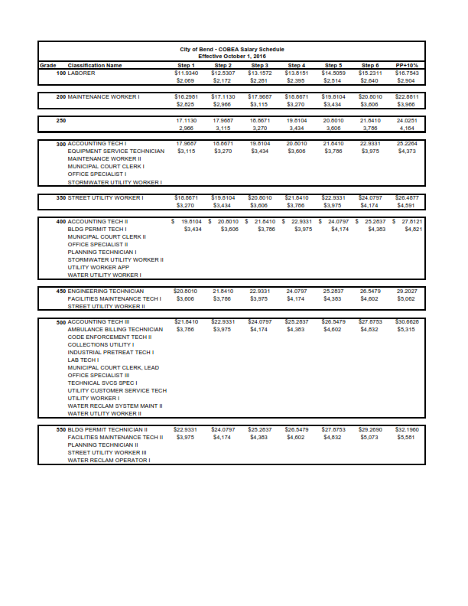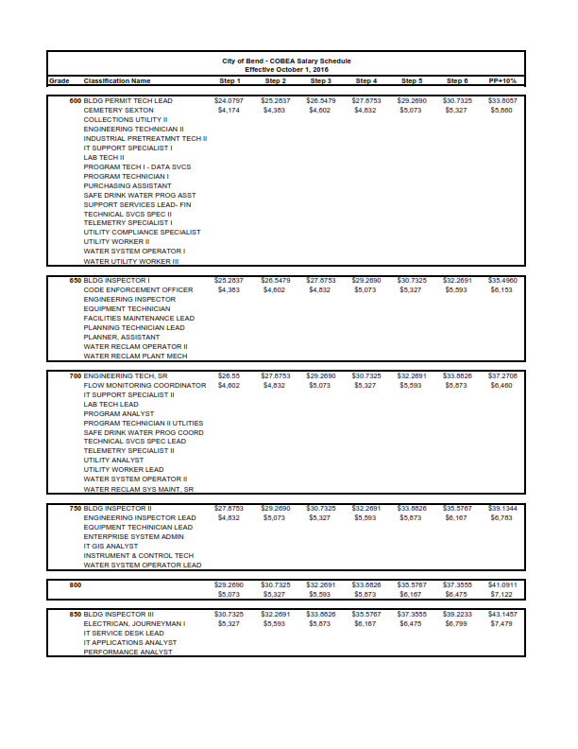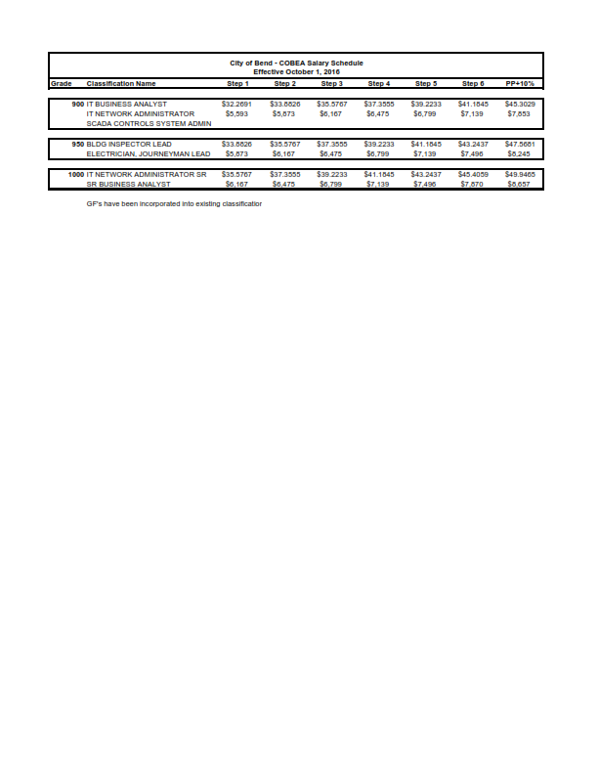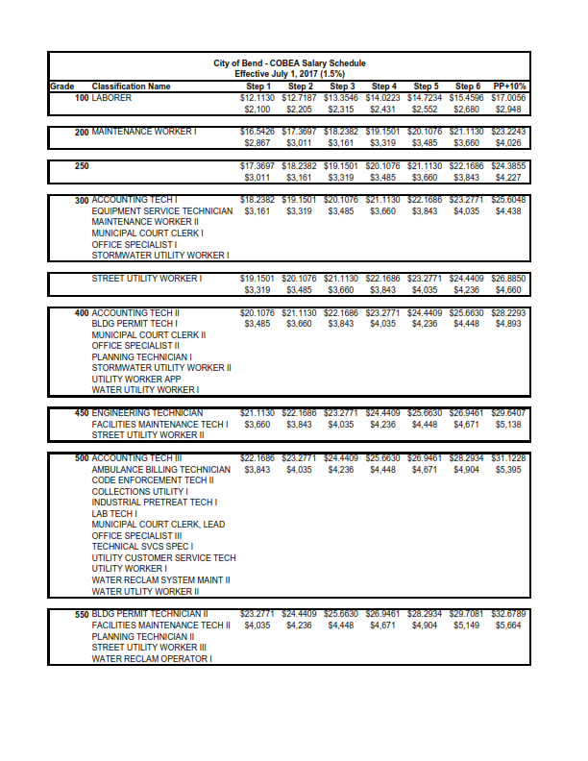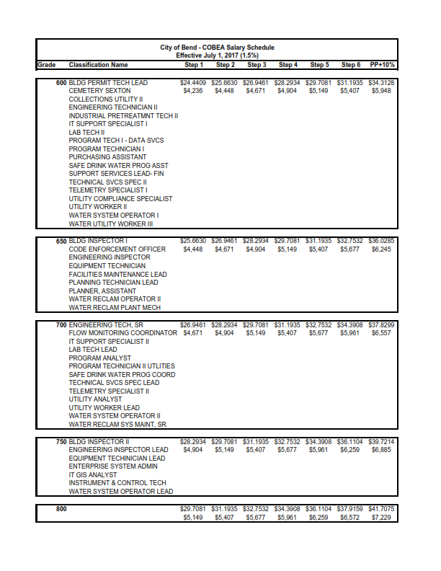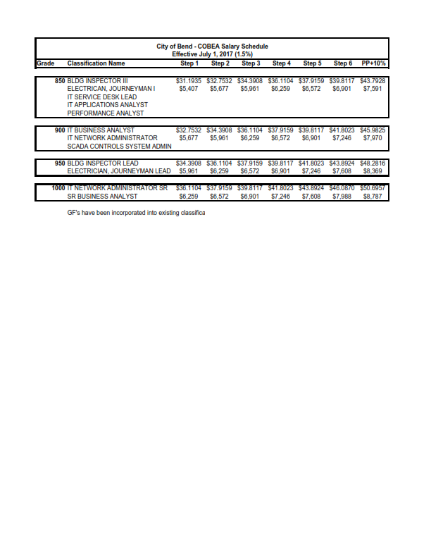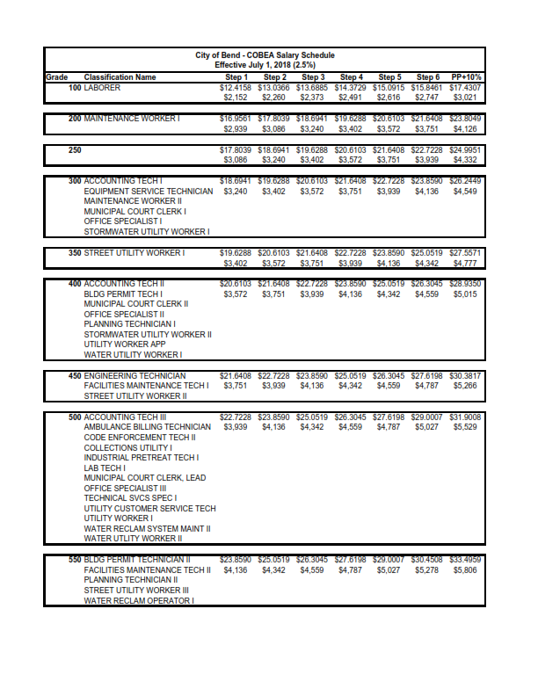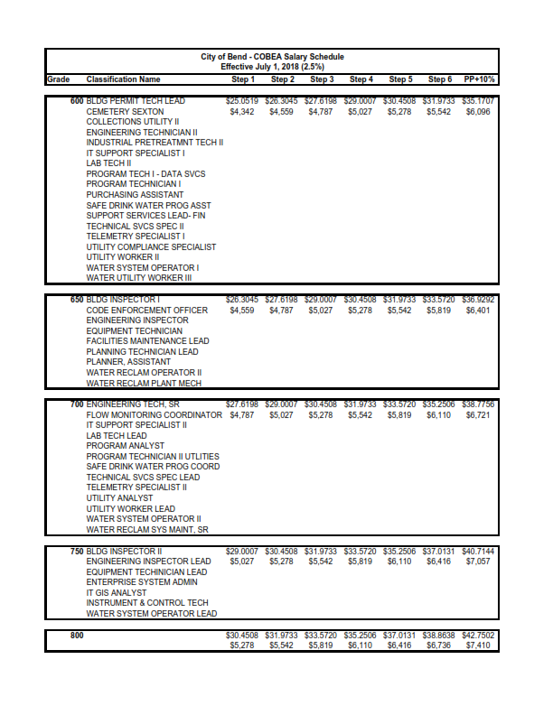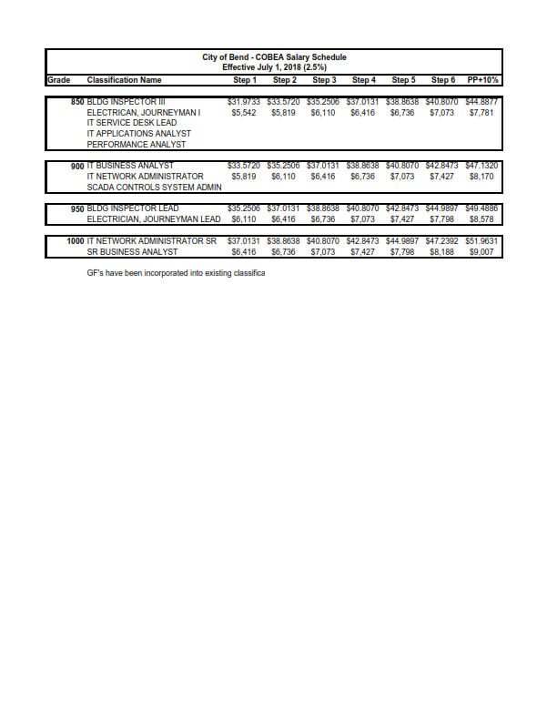Memorandum of Understandings

